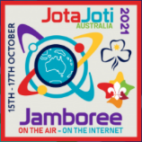

Jamboree On The Air 2021
Radio Message Passing – Battleship Game
Radio Operators & Scout Leaders Guide

Background

Battleships is a strategy-based game where each player/team layout on grid squares their defined battleships that the opposing player/team cannot see. Each competing parties or groups take turns to call “shots or attacks” (grid reference i.e. “C2”) at each other’s ships, with the winning objective being to sink all opposing fleets. Each player has a ruled grid where they layout their fleet before commencing the game. They also have a ruled grid for their opposing team upon which they can record hits and miss results of their attempted attack.

Network Setup

For the JOTA weekend, we will be playing a game of Battleships over the airwaves, where the patrols (small groups of 4-6 scouts) will be given a grid each. Each patrol will be assigned a Scout Leader to supervise and assist them. They will also have an amateur radio operator to relay radio messages on behalf of the scouts. The amateur radio operator will be connected to a repeater, either the VK2RWC Chatswood repeater or the VK2RBM Lawson repeater. About three other patrols will also be on at the same time as well. A net controller will oversee the coordination of radio messages between the operators.

Figure 2: Amateur Radio Network Setup

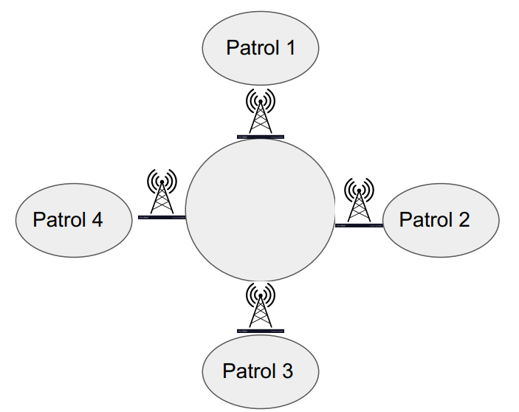
Repeater

Radio operator 1

Radio operator 2

Radio operator 4

Radio operator 3

Radio Net Controller

The Zoom link to access the game will be advertised in the programme for the weekend. This Zoom link is where the Scouts and leaders will also log into.

Joining Battleships

Upon joining the main Zoom session, an introduction will be given, and each Scout will be organized into patrols along with a Scout leader and radio operator. Someone in each patrol, probably the Scout leader will be granted (co-host) rights to be able to share their patrols grid layout within their patrol. Co-host rights will be given by the main Zoom host on the actual time and day of the session. Each patrol with leader and operator will then be moved to their own breakout room where they will organize themselves and plan their layout grid. The radio net controller will not be assigned to a breakout room but will remain unassigned. Ship layouts can only be horizontal or vertical, not diagonal. We suggest that one or two people in the patrol be the strategist and planning where to attack the other patrol’s ships. One or two persons should also be the recorder of hits and misses on their own fleet as well as hits and misses on other patrols fleets.

Once the fleet has been laid out the person with Co-Host rights will then share their grid in their Zoom breakout room so each patrol member can see what is happening. This sharing is only visible within the breakout room and is not visible to other patrols. The radio operator, Scout leader and scout patrol must remain in the breakout room for the entire duration of the game.

The grid for the Battleships game over the weekend will be a 6x6 grid where participants will put down four vessels onto the grid, as shown in the example below. Each patrol will also have a blank grid for each of the other competing patrols where you can record any hits or misses on each of the other patrols grids. This will assist in strategy of where to attack.

Figure 1: The sheet the patrols get
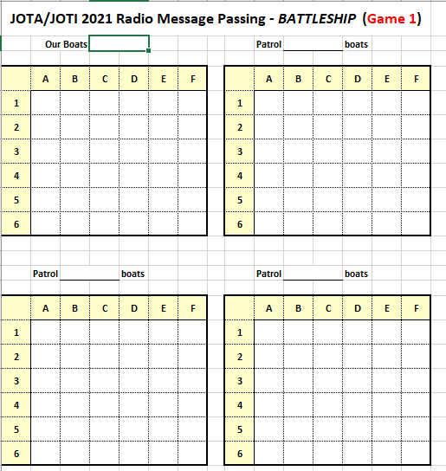

Key to the ships and squares is:

Carrier = 5 coloured squares,
Battleship = 4 coloured square
Cruiser = 3 coloured square
Submarine = 2 coloured squares

When they have finished laying out their ships on the grid, this will be shared within the breakout room so each person in the room (patrol) can see what they have setup and how the game progresses. The patrol remains within the breakout room and communication to other patrols will be via the radio operator and net controller. Communication between radio operators and net controllers must occur over the designated repeater for the session.

Game and Message Flow

The net controller will then commence the game by calling upon the first patrol’s radio operator for their attack co-ordinate. Radio operators call sign will be used to identify the patrol. The patrol leader or assigned strategist will advise the radio operator of their first attack co-ordinate who will then pass it on to the net controller. All radio operators will hear the co-ordinate and will advise their patrol what it is, where the patrol will record if it was a hit or a miss on their fleet. It is best if the hit or miss can be done on the shared grid sheet within the Zoom breakout room so that everyone in the patrol can see the progress.
The net controller will then ask each of the other patrol’s radio operator if the attack was a hit or a miss whereupon the radio operator will respond accordingly.

When a patrol is asked for their attack co-ordinate, it is important that the patrol responds fairly quickly otherwise the game will drag on and on. If a patrol has not given an attack co-ordinate within 20 seconds, they will be given an additional 10 seconds to respond. If no response is given for a maximum of 30 seconds, that patrol will miss their turn and the net controller will move onto the next patrol. This is where it is important that the patrol have someone to be the attacking strategist whose role will be solely to plan where to hit other patrols fleets.

For example, a game scenario is below

Patrol | Assigned Radio Operator | Repeater
Patrol 1 | Radio Operator 1 (RO1) – attacking patrol | Net Controller (NC)
Patrol 2 | Radio Operator 2 (RO2) | Net Controller (NC)
Patrol 3 | Radio Operator 3 (RO3) | Net Controller (NC)
Patrol 4 | Radio Operator 4 (RO4) | Net Controller (NC)

The flow of amateur radio messages would look something like this

Operator | Message
NC | RO1, your attack coordinate
RO1 | A1
NC | RO2, hit or miss
RO2 | A1 is a hit
NC | RO3, hit or miss
RO3 | A1 is a miss
NC | RO4, hit or miss
RO4 | A1 is a hit
NC | RO2, your attack coordinate

This process is then repeated continuously in the same round robin order for the next attacking patrol and responding hits or misses until there is one fleet left standing.

Figure 3: A grid with a hit and miss
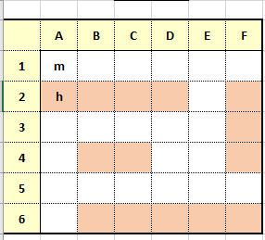

Sinking Vessels

When it gets to the stage where an entire ship is hit, the radio operator says something along the lines of boat sunk. For example, in the picture below, the radio operator assigned to that patrol would say something along the lines of

VK2GOH: “Cruiser sunk”

Figure 4: A sunk vessel
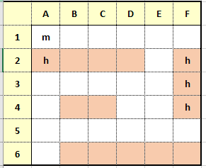

The process then continues until eventually all ships of that patrol’s fleet is sunk. When all ships on a patrol’s fleet is sunk, the message going out will be along the lines of

VK2GOH: “Fleet sunk”

That patrol is then eliminated from the round and listens in to the remaining patrols battle each other out

Winning the Round

The last fleet remaining is the winner.

If we run out of time and there is more than one patrol still in the game, then the net controller will call time and ask the remaining patrols to calculate the number of fleet squares that have not been hit or sunk. In the above example there are 10 squares not hit so that radio operator will advise that they have 10 squares not touched. The patrol with the highest number of remaining squares will be the winning patrol.

Radio operator responsibilities:
- to listen to any briefings or communications as necessary
- The radio operator is there to facilitate radio communications by:
  - ensuring the patrol can hear the radio communications over zoom
  - Listening to attack coordinates from the Patrol in the breakout room
  - Passing on the attack coordinates to the net controller via the 2m repeater assigned for the session
  - Listening to Hit or miss from the other patrol’s radio operator
  - passing on the hit or miss from the other patrols to their patrol
  - passing on other patrols attack coordinates to their patrol
  - returning to the net controller any hit or miss by their patrol
  - if one of their patrol’s ships is sunk, inform net control
  - if all of their patrol’s ships are sunk, inform net control

Scout leader responsibilities
- to listen to any briefings or communications as necessary
- guide the scouts with any decision-making such as setting up who is doing what task in the patrol
- possible roles for patrol members are:
  - grid square scribe
  - ship placement
  - attack coordinator
  - incoming attack coordinator
  - radio operator liaison
  - patrol lead
- oversee the safe well-being of the patrol
- ensure all people act appropriately throughout the session
- report any issues to the coordinator

